RIMES SAHF Forum - Weekly Climate Monitoring and Outlook
Forum date: 2026-10-22 | data as of 2026-10-21
Observations, drought, medium-range and extended-range forecasts for RIMES South Asia member countries

Key messages
- Sri Lanka and Maldives: very wet week. Satellite estimates give widespread 7-day totals above 100 mm over the Maldives and around Sri Lanka, locally over 300 mm. CPC gauge analysis shows Sri Lanka 100-200 mm above normal for 13-19 October.
- Bay of Bengal: two lows, a third expected. IMD: a low formed over the southwest Bay off Tamil Nadu on 21 October. A new low is expected over the southeast Bay around 23 October, moving northwest and intensifying over the following 3 days. RSMC New Delhi has no active cyclone bulletin yet.
- South India heavy rain continues. Heavy to very heavy rain over Tamil Nadu on 21-22 October (Chennai 11-12 cm in 24 h); heavy rain over Kerala, Lakshadweep, Andaman and Nicobar to 26 October.
- North and central South Asia dry and warm. Early-October rainfall was below 20 percent of normal across most of central and northern India, Nepal, Bangladesh and Myanmar. Day and night temperatures are above normal over much of India.
- Next 7 days: rain shifts into the Bay. NCMRWF, ECMWF and GFS agree on the heaviest rain over the central and southern Bay and the Andaman Sea, with continued showers over Sri Lanka, south India and the Maldives.
- Weeks 2-4: warm, rain signal mixed. All centres keep India warmer than normal. Week 2 (23-29 Oct) is wetter than normal over south India, Sri Lanka and the Bay. In week 3, NCMRWF and ECMWF turn drier over Sri Lanka and the south peninsula while IMD MME stays wet, so confidence is low.

01 Significant event
Heavy rainfall over Sri Lanka and the Maldives; low-pressure systems over the Bay of Bengal

Sri Lanka: 100-200 mm in a week across most of the island
Significant event | Sri Lanka
Sri Lanka has had the heaviest rainfall of the RIMES countries this week. In the 24 hours to 05:30 this morning, the heaviest falls were along the southwest coast between Colombo and Galle, 40 to 60 mm, and around Batticaloa in the east, with a satellite maximum of about 120 mm just offshore. Over seven days, 100 to 200 mm fell over most of the island, highest from the north-central province through Kandy to the hill country. The CPC gauge anomaly confirms this is 100 to 200 mm above normal for the week. Members should note the flood and landslide risk in the central highlands while soils are saturated. Rain continues this week; NCMRWF's extended range for Sri Lanka turns drier than normal from the end of October.
- Past 24 h: heaviest on the southwest coast (Colombo to Galle, 40-60 mm) and around Batticaloa (50-70 mm); satellite maximum about 120 mm just off the west coast.
- Past 7 days: 100-200 mm over most of the island, highest from the north-central province through Kandy to the highlands.
- Anomaly: CPC unified gauge analysis puts Sri Lanka 100-200 mm above normal for 13-19 October; PRISM shows the first October dekad at 150-300 percent of normal.
- Outlook: showers continue this week; the NCMRWF Sri Lanka ERP turns drier than normal in week 3 (30 Oct-5 Nov).
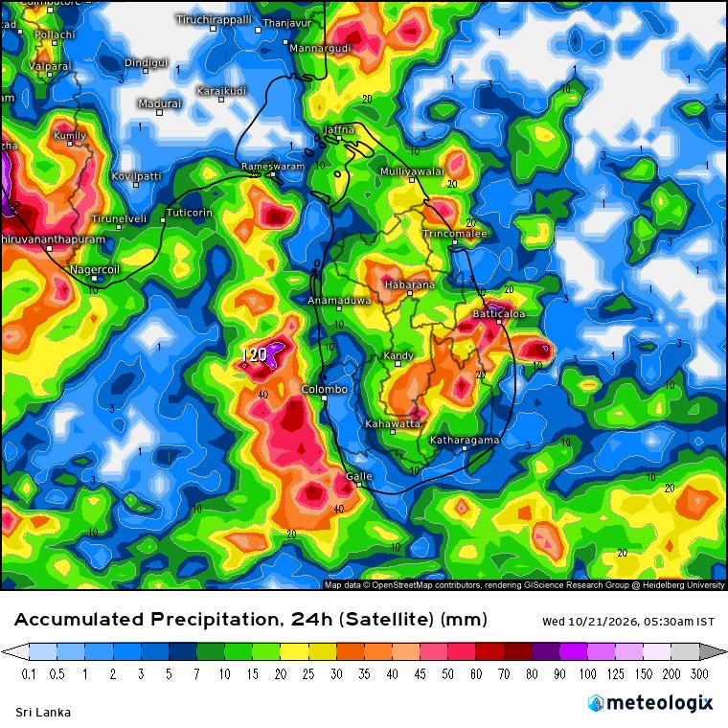
Accumulated precipitation, 24 h (satellite) - Sri Lanka (ending 2026-10-21 00:00 UTC). Source: Meteologix (satellite rainfall).
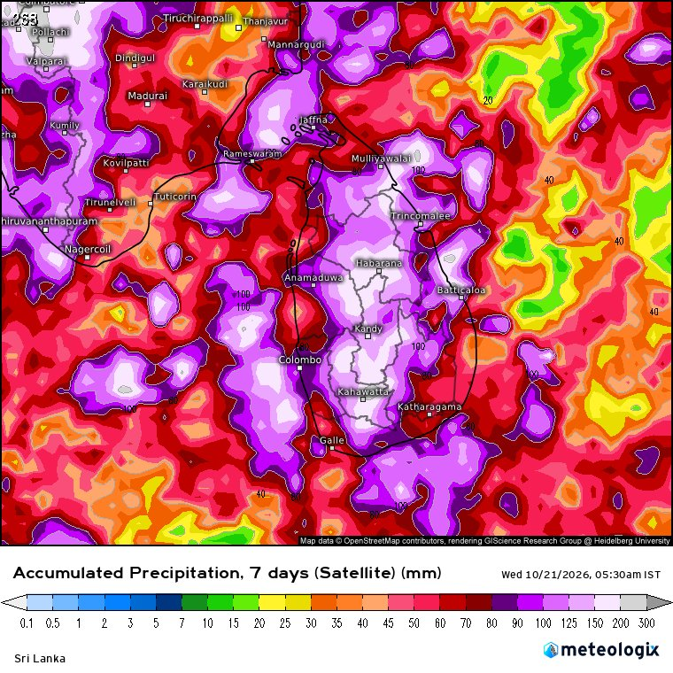
Accumulated precipitation, 7 days (satellite) - Sri Lanka (ending 2026-10-21 00:00 UTC). Source: Meteologix (satellite rainfall).
Products: Meteologix (satellite rainfall)

Maldives: persistent heavy rain across the atolls and adjoining seas
Significant event | Maldives
The Maldives has also been very wet. The seven-day satellite total exceeds 100 mm over most of the domain and is locally above 300 mm west of the atolls. This is associated with deep convection over the equatorial Indian Ocean and the low over the southwest Arabian Sea, which IMD expects to move towards the Somalia coast. The models keep rain over the Maldives through the coming week, and IMD has issued a fishermen warning for the southwest Arabian Sea and the Lakshadweep area.
- Past 7 days: satellite totals of 100-200 mm over most of the Maldives domain, locally above 300 mm to the west of the atolls.
- Past 24 h: scattered 20-60 mm with a local satellite maximum of about 190 mm in the west of the domain.
- Cause: active convection over the equatorial Indian Ocean and the southwest Arabian Sea low (IMD), with squally weather over the southwest Arabian Sea.
- Next days: NCMRWF, ECMWF and GFS all keep heavy rain over the Maldives and Lakshadweep sea area through the coming week.
- Marine: IMD fishermen warning for the southwest Arabian Sea on 21-22 October and off Kerala-Karnataka-Lakshadweep on 22-24 October.
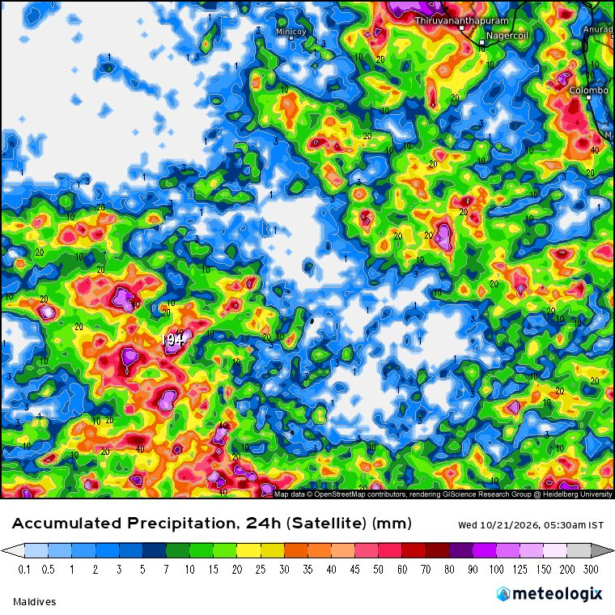
Accumulated precipitation, 24 h (satellite) - Maldives (ending 2026-10-21 00:00 UTC). Source: Meteologix (satellite rainfall).
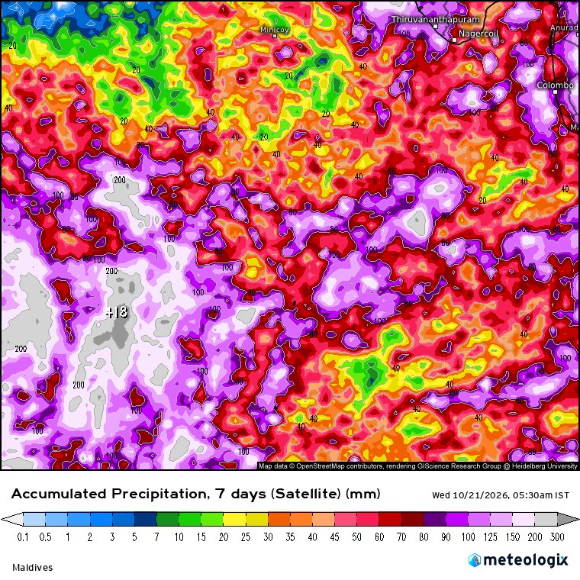
Accumulated precipitation, 7 days (satellite) - Maldives (ending 2026-10-21 00:00 UTC). Source: Meteologix (satellite rainfall).
Products: Meteologix (satellite rainfall)

Bay of Bengal: a stronger low likely from 23 October
Significant event | Bay of Bengal
The second part of the significant event is the Bay of Bengal. IMD's analysis this morning has a low off the Tamil Nadu coast, and expects a new low over the southeast Bay around the 23rd that moves northwest and intensifies over the following three days. ECMWF shows the circulation at 72 hours and GFS accumulates very large rainfall totals over the central Bay and Andaman Sea over the week. RSMC New Delhi has not issued a tropical cyclone bulletin yet, so this is a watch situation. Myanmar, Bangladesh and the Indian east coast should follow the RSMC bulletins closely from the 23rd.
- Low-pressure area over the southwest Bay off the Tamil Nadu coast; circulation up to 5.8 km.
- Upper-air circulation over the Gulf of Thailand emerging into the north Andaman Sea; a low is likely over the southeast and adjoining east-central Bay around 23 October, moving northwest and intensifying over the next 3 days.
- Models put the heaviest rain over the central Bay and Andaman Sea in the next 7 days (GFS locally above 300 mm at sea).
- Watch: Myanmar, Bangladesh and the Odisha-Andhra coast for the track; RSMC New Delhi special bulletin: NIL as of 21 Oct.
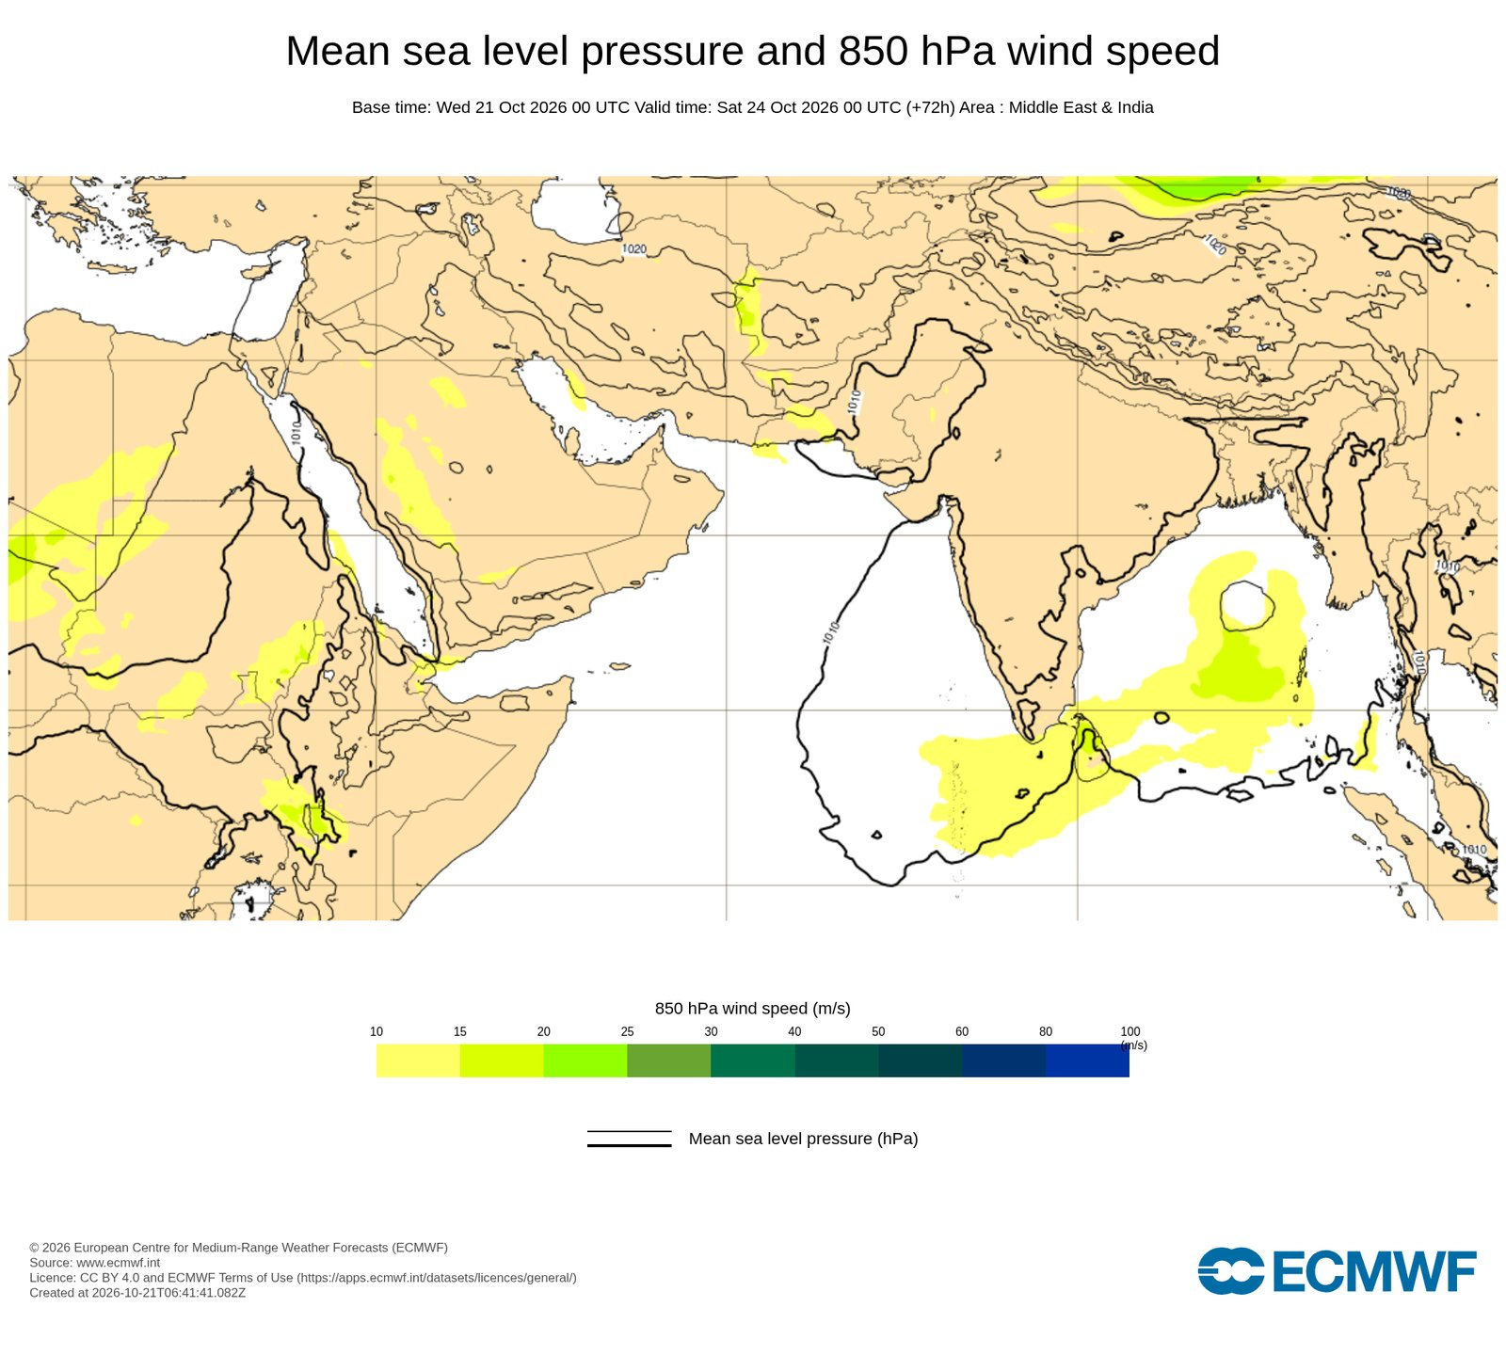
ECMWF HRES MSLP and 850 hPa wind, +72 h (base 21 Oct 00Z; valid 24 Oct 00Z). Source: ECMWF open charts (CC-BY-4.0).
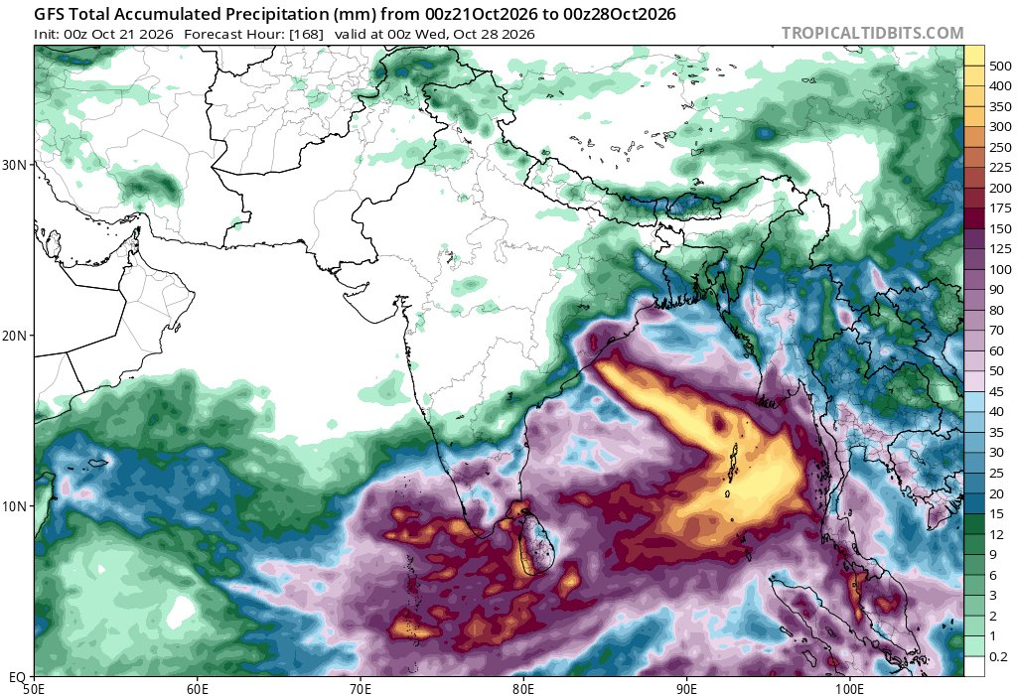
GFS total accumulated precipitation (mm), 168 h (init 21 Oct 2026 00Z to 28 Oct 00Z). Source: Tropical Tidbits (GFS).
Products: ECMWF open charts (CC-BY-4.0); Tropical Tidbits (GFS)

02 Observed weather and anomalies
Week ending 21 October 2026: satellite, rainfall, temperature and wind

IMD All India bulletin: observed weather and systems, 21 October
IMD significant weather summary
This is the IMD summary of significant weather. In the past 24 hours, rain was concentrated in the south and over the islands, with heavy to very heavy rain over Tamil Nadu: Chennai recorded 11 to 12 centimetres. The rest of the country was largely dry. Temperatures are above normal in many areas, especially the night-time minimum in the northeast and Rajasthan; Rajkot reached 40.6 degrees. On systems: a low over the southwest Arabian Sea is moving away towards Somalia, a low has formed off Tamil Nadu, and a new low is expected over the southeast Bay around the 23rd.
Observed (24 h to 05:30 IST)
- Rain at most places over Andaman and Nicobar Islands and Coastal Karnataka; at many places over Rajasthan, Tamil Nadu, Kerala, Rayalaseema, west Madhya Pradesh, coastal Andhra Pradesh and Lakshadweep. Dry over the rest of the country.
- Heavy to very heavy rain at isolated places over Tamil Nadu, Puducherry and Karaikal.
- Chennai (Meenambakkam) 12 cm, Chennai (Nungambakkam) 11 cm, Pamban and Nagapattinam 5 cm, Thiruvananthapuram 5 cm.
Temperature (20 Oct)
- Minimum temperatures markedly above normal (more than 5.1 C) at isolated places over Assam and Meghalaya, Sub-Himalayan West Bengal and Sikkim, east Rajasthan and Madhya Maharashtra.
- Maximum temperatures markedly above normal at isolated places over Assam and Meghalaya and Telangana.
- Highest maximum 40.6 C at Rajkot (Gujarat); lowest minimum over the plains 11.2 C at Mandi (Himachal Pradesh).
Weather systems
- Low over the southwest Arabian Sea (weakened from a well-marked low), moving west-northwest then towards the Somalia coast on 22 Oct.
- Low over the southwest Bay off the Tamil Nadu coast, with a trough to north coastal Andhra Pradesh.
- Circulation over the Gulf of Thailand entering the north Andaman Sea; new low likely over the southeast Bay around 23 Oct, intensifying over 3 days.
- Western disturbance-related rain over Jammu-Kashmir, Himachal and Uttarakhand on 23-26 Oct.
Source: IMD All India Weather Summary and Forecast Bulletin, issued 21 Oct 2026, 08:55 IST

Convection concentrated over the south peninsula, Sri Lanka and the seas
Satellite observations
The satellite picture shows where the active weather is. The coldest cloud tops, below minus 70 degrees, are over the Tamil Nadu and Andhra coasts, around Sri Lanka and over the southeast Arabian Sea. Lightning detections follow the same pattern. The north of the region is largely clear, consistent with the post-monsoon season.
- Coldest cloud tops (below -70 C) over coastal Andhra Pradesh and Tamil Nadu, the Gulf of Mannar, Sri Lanka and the southeast Arabian Sea.
- Lightning clusters along the Kerala coast, coastal Andhra Pradesh, northern Sri Lanka and over the Bay.
- Northern and central India, Pakistan, Nepal and Bangladesh largely cloud-free.
Products: Meteologix

Satellite rainfall: 24-hour and 7-day totals over South Asia
Observed rainfall
Satellite rainfall totals for the past 24 hours and 7 days. The heaviest totals, above 100 mm in seven days, lie over the southern Bay, Sri Lanka, the Maldives and the equatorial ocean. Over land, the Tamil Nadu and Andhra coasts and Kerala stand out. North India had only light rain.
- 7-day totals exceed 100 mm over the southern Bay of Bengal, Sri Lanka, the Maldives and the equatorial Indian Ocean.
- Heavy falls along the Tamil Nadu and Andhra coasts and over Kerala.
- Northwest India and Pakistan picked up light to moderate rain from the passing western disturbance; central India stayed mostly dry.
Products: Meteologix (satellite rainfall)

Rainfall anomalies: weekly, monthly and seasonal
Rainfall anomaly | NOAA CPC gauge analysis
CPC unified gauge rainfall anomalies for 7, 30 and 90 days. In the past week Sri Lanka and parts of south India are well above normal, while most of central India, Bangladesh and Myanmar are 10 to 50 mm below normal. Over 30 days the central Indian deficit is clearer, with surpluses over northwest India and eastern India from late-season rain. Over 90 days, northwest India and Pakistan are wetter than normal while parts of peninsular India, Nepal and Myanmar are drier.
Products: NOAA CPC (Unified gauge)

Rainfall as a percentage of normal: dekad, 1 month and 3 months
Rainfall anomaly | WFP PRISM (CHIRPS)
The same picture from CHIRPS rainfall in PRISM, as a percentage of the long-term average. In the first dekad of October most of central and northern India, Nepal, Bangladesh and Myanmar received less than 20 to 40 percent of normal, which is typical of the monsoon withdrawal but drier than usual. Sri Lanka, Kerala and Pakistan's northeast were 150 to 300 percent of normal. Over three months the deficit belt runs across central and peninsular India.
Products: WFP PRISM (CHIRPS/MODIS via WFP HDC WMS)

Temperature: warmer than normal over most of India
Temperature anomaly
Temperature anomalies. The latest CPC daily analysis has India, Bangladesh and Myanmar one to three degrees above normal. The MODIS land surface temperature for the last September dekad was still below normal over north and central India after the late monsoon rain, so the warming has come since the rain stopped. IMD's station data agree, with minimum temperatures notably above normal in the northeast and Rajasthan.
- CPC 2 m temperature anomaly: India, Bangladesh and Myanmar 1-3 C above normal; locally higher over Gujarat and Maharashtra.
- MODIS daytime land-surface temperature (late September dekad) was below normal over much of north and central India after late-season rain.
- IMD reports maximum and minimum temperatures above normal over the northeast, Rajasthan and Maharashtra on 20 October.
Products: NOAA CPC; WFP PRISM (CHIRPS/MODIS via WFP HDC WMS)

Low-level winds: easterly anomalies across the Bay and south India
Wind anomaly | 850 hPa
850 hectopascal wind anomalies. Over the past week there are easterly anomalies across the southern Bay, Sri Lanka and south India, the pattern that comes with the onset of the northeast monsoon. The strongest anomalies in the domain are further east over the South China Sea. Over 30 days, anomalies over the north of our region are weak.
- 7-day 850 hPa anomalies are easterly over the southern Bay, Sri Lanka and south India, typical of the northeast-monsoon onset phase.
- The strongest anomalies (5-10 m/s) lie over the South China Sea and western Pacific.
- 30-day anomalies are weak over the north of the region.
Products: NOAA CPC (CDAS reanalysis)

03 Drought monitoring
Soil moisture, standardised indices, dry spells and flash-drought indicators

Soil-moisture deficit over central and peninsular India
Drought monitoring
Drought indicators. The CPC soil-moisture model shows a marked deficit over central and peninsular India, with surpluses over the northeast and Myanmar. The one-month SPEI is dry over central and western India and wet over northwest India and Pakistan. PRISM dry-spell maps show more than 26 dry days over Pakistan and Afghanistan, which is normal for the season, and 13 to 20 dry days across central India, while the south and Sri Lanka had rain in the past few days.
Products: NOAA CPC (Leaky bucket); NOAA CPC flash drought monitor; WFP PRISM (CHIRPS/MODIS via WFP HDC WMS)

Flash-drought indicators: evaporative demand and soil moisture
Flash drought | NOAA CPC
Flash-drought indicators for the region. The soil-moisture percentile and the one-month runoff index are lowest over southeast India; the current northeast-monsoon rain should ease that. Evaporative demand is high over Sindh and parts of west India. Vegetation health is still good over most of India after the monsoon, so there is no widespread flash drought, but it is worth watching areas where soils stay dry into November.
- Soil moisture percentile and SRI are lowest over southeast India (Andhra Pradesh, Tamil Nadu interior) before the current rain.
- EDDI shows high evaporative demand over Pakistan's Sindh and parts of west India.
- Vegetation health remains good over most of India after the monsoon; watch areas where dry soils persist into November.
Products: NOAA CPC flash drought monitor

04 Medium-range forecasts
IMD warnings, NCMRWF deterministic and ensemble, ECMWF, GFS: next 1-10 days

IMD: heavy rain warnings for the south and the islands, 21-26 October
IMD forecast and warnings
IMD's forecast and warnings for the next five days. The heaviest rain is expected over Tamil Nadu on the 21st and 22nd, with heavy rain also over Kerala, Lakshadweep, Karnataka and the Andaman and Nicobar Islands through the 26th. Squally weather is expected over the southwest Arabian Sea, off the Kerala and Karnataka coasts and over the Andaman Sea, so there are fishermen warnings. In the north, a western disturbance brings scattered rain to the hills and the northwest plains on the 23rd to 26th.
21-22 October
- Heavy to very heavy rain at isolated places over Tamil Nadu, Puducherry and Karaikal.
- Heavy rain over Andaman and Nicobar, Kerala, Lakshadweep and south interior Karnataka (and Andhra Pradesh on the 21st).
- Thunderstorms with gusts of 40-50 km/h over Tamil Nadu; squally weather over the southwest Arabian Sea.
23-26 October
- Heavy rain at isolated places over Tamil Nadu, Kerala, Lakshadweep, Andaman and Nicobar and Karnataka.
- Thunderstorms with gusts of 40-50 km/h over Andaman and Nicobar; squally weather over the Andaman Sea and off Kerala-Karnataka.
- Fairly widespread rain over Andaman and Nicobar through 26 Oct; scattered rain over Odisha on 26 Oct.
North and central India
- Scattered rain over Jammu-Kashmir, Himachal and Uttarakhand on 23-26 October with a western disturbance.
- Scattered rain over Punjab, Haryana, Delhi and Rajasthan on 24-25 October; thunderstorms over west Rajasthan on the 24th.
- Scattered rain and thunderstorms over west Madhya Pradesh on 21-23 October.
Source: IMD All India Weather Summary and Forecast Bulletin, issued 21 Oct 2026, 08:55 IST

NCMRWF daily rainfall forecast: days 1, 3, 5 and 7
NCMRWF | Mithuna-GLB deterministic
NCMRWF's global model rainfall for days 1, 3, 5 and 7 from today's run. Days 1 to 3 keep heavy rain over south India, Sri Lanka, the Maldives and the southern Bay. By day 5 to day 7 the heaviest rain organises over the central and north Bay towards Odisha and Bangladesh, consistent with the low IMD expects to intensify.
Products: NCMRWF NCUM-G (Mithuna-GLB)

NCMRWF 850 hPa wind and MSLP: circulation develops over the Bay
NCMRWF | Mithuna-GLB deterministic
NCMRWF 850 hectopascal wind and mean sea level pressure for days 1, 3 and 5. A cyclonic circulation is visible over the Bay by day 3 and becomes better defined by day 5 as it moves northwest. The northeast monsoon easterlies are established over the south peninsula and Sri Lanka.
Products: NCMRWF NCUM-G (Mithuna-GLB)

NCMRWF ensemble: probability of heavy rain, day 3
NCMRWF | NEPS-G ensemble
The NCMRWF ensemble gives probabilities. The panels show the ensemble mean for day 3 and the probability of rainfall above thresholds from 2.5 mm to 204 mm per day. High probabilities of more than 15.6 mm per day cover south India, Sri Lanka and the southern Bay; the probability of very heavy rain is highest over the Bay and the Andaman Sea. Days 1 and 5 are on the NCMRWF dashboard.
Products: NCMRWF NEPS-G (12 km ensemble)

ECMWF: accumulated rainfall to 3 and 7 days, and 850 hPa wind
ECMWF | HRES
ECMWF's high-resolution forecast from 00 UTC today. The three-day accumulation keeps the heaviest rain over Sri Lanka, south India and the seas; by seven days the accumulation exceeds 100 to 300 mm over the central and south Bay. The 850 hectopascal winds at 72 hours show the circulation over the southeast Bay.
Products: ECMWF open charts (CC-BY-4.0)

GFS vs ECMWF: total rainfall and MSLP
Model comparison | Tropical Tidbits
A side-by-side of GFS and ECMWF. Both models put the largest totals over the Bay. GFS is wetter and more organised, with a stronger system tracking north towards Myanmar and Bangladesh; ECMWF keeps the rain further south and over the Andaman Sea. The difference in track and intensity is the main uncertainty for the coming week.
Products: Tropical Tidbits (ECMWF); Tropical Tidbits (GFS)

Forecast slices: rainfall and temperature anomaly for days 1-3, 4-6, 7-10
Climate Reanalyzer | GFS
Climate Reanalyzer slices the GFS forecast into days 1 to 3, 4 to 6 and 7 to 10. The rain moves from Sri Lanka and the equatorial ocean in days 1 to 3 into the Bay in days 4 to 6, and towards the northern Bay coast in days 7 to 10. Temperatures stay above normal over most of India and Pakistan throughout.
Products: Climate Reanalyzer (GFS)

05 Extended range (ERP)
Weeks 1-4 from NCMRWF, IMD MME, ECMWF and NCEP GFS: rainfall, temperature and wind anomalies

Rainfall anomaly, weeks 1-4: NCMRWF and IMD MME
ERP rainfall | NCMRWF and IMD
Extended-range rainfall anomalies from NCMRWF, issued 15 October, and the IMD multi-model ensemble, issued 14 October. Both are wet in week 2 over the south peninsula, Sri Lanka and the Bay. They disagree in week 3: NCMRWF turns drier over Tamil Nadu and Sri Lanka, while the IMD ensemble stays wet over the Bay and Sri Lanka. Week 4 is near normal over India.
- Week 2 (23-29 Oct): both wetter than normal over the south peninsula, Sri Lanka and the Bay.
- Week 3 (30 Oct-5 Nov): NCMRWF drier over Tamil Nadu and Sri Lanka; IMD MME still wet over the Bay and Sri Lanka.
- Week 4: near normal over India in both; IMD MME wet over the Andaman Sea and Myanmar coast.
Products: IMD Extended Range Forecast (MME); NCMRWF ERP (CNCUM coupled)

ECMWF extended range: weekly precipitation anomaly
ERP rainfall | ECMWF
ECMWF's extended-range weekly precipitation anomalies from 20 October. For 26 October to 2 November ECMWF is drier than normal over the southern Bay and the equatorial ocean but wetter over the northern Bay, Bangladesh and Myanmar, consistent with the system moving north. In the following two weeks it is drier than normal over Sri Lanka and the far south of India.
Products: ECMWF open charts (CC-BY-4.0)

ECMWF (GWIS): rainfall anomaly, weeks 2-5
ERP rainfall | ECMWF via JRC GWIS
The same ECMWF monthly system as processed by JRC GWIS, for weeks 2 to 5. It shows a wet anomaly over the Bay of Bengal, eastern India and Bangladesh in week 2, then a wet signal over Myanmar and the Bay, with dry anomalies over the western Pacific.
Products: ECMWF extended range via JRC GWIS/EFFIS

GFS week 1 and week 2 rainfall anomaly
ERP rainfall | NCEP GFS (CPC)
GFS weeks 1 and 2 from the CPC South Asia page. Week 1 is strongly wet over the Bay and the Andaman Sea and dry over Tamil Nadu and Sri Lanka. Week 2 turns dry over south India and Sri Lanka and wet over Bangladesh and northeast India.
Products: NCEP GFS via NOAA CPC

Tmax anomaly: India warm through mid-November
ERP temperature
Temperature in the extended range. NCMRWF and the IMD ensemble both keep maximum temperatures 1 to 3 degrees above normal over most of India in weeks 2 to 4, with the largest anomalies over the north and northeast; the IMD ensemble has some cooler areas over the south peninsula in the wetter week 2. ECMWF's 2-metre temperature anomaly is warm across the whole region.
Products: ECMWF open charts (CC-BY-4.0); IMD Extended Range Forecast (MME); NCMRWF ERP (CNCUM coupled)

Tmin anomaly, and GFS week-1 Tmax and Tmin
ERP temperature
Night-time temperatures are also expected above normal, by 0.5 to 2 degrees over most of India in NCMRWF and the IMD ensemble, with large anomalies over Ladakh. GFS week 1 maximum temperatures are 2 to 6 degrees above normal over Pakistan, north India and Myanmar.
Products: IMD Extended Range Forecast (MME); NCEP GFS via NOAA CPC; NCMRWF ERP (CNCUM coupled)

850 hPa wind anomaly: cyclonic anomaly over the Bay in week 2
ERP wind
Low-level wind anomalies. NCMRWF's week 2 shows a clear cyclonic anomaly over the central Bay, which matches the low IMD expects to develop. GFS week 1 has strong westerly anomalies across the southern Bay into Myanmar and Thailand. By weeks 3 and 4 the anomalies weaken.
Products: IMD Extended Range Forecast (MME); NCEP GFS via NOAA CPC; NCMRWF ERP (CNCUM coupled)

ECMWF (GWIS): 2 m temperature anomaly, weeks 2-5
ERP temperature | ECMWF via JRC GWIS
GWIS temperature anomalies from the ECMWF monthly system for weeks 2 to 5: above normal over Pakistan, northern India and the Tibetan Plateau, near normal over the south.
Products: ECMWF extended range via JRC GWIS/EFFIS

Sri Lanka weekly outlook and the Madden-Julian Oscillation
ERP | Sri Lanka and MJO
Two final extended-range products. NCMRWF's Sri Lanka outlook is near normal for the next two weeks and below normal across the island in week 3. The MJO is weak, inside the unit circle, and NCMRWF's ensemble drifts it towards phases 8 and 1 into November. It is not expected to enhance Indian Ocean convection in the next two weeks.
- Sri Lanka: near normal in weeks 1-2, below normal (-5 to -10 mm/day) island-wide in week 3, near normal in week 4.
- MJO: weak (inside the unit circle); the ensemble drifts towards phases 8-1 into November, so little MJO support for Indian Ocean convection in the near term.
Products: NCMRWF ERP (BIMSTEC Sri Lanka); NCMRWF ERP (CNCUM coupled)

Ocean drivers: Pacific warming and the Indian Ocean Dipole
Seasonal drivers | NCMRWF coupled model
Seasonal drivers from NCMRWF's coupled model. The SST forecast keeps a strong warm anomaly over the central and eastern equatorial Pacific from October through February, El Nino conditions. The Nino 3.4 and Indian Ocean Dipole plumes show the expected evolution; members should consider the El Nino context when interpreting the northeast monsoon outlook.
Products: NCMRWF seasonal (coupled)

RIMES member countries: the week ahead and weeks 2-4
Country | Past week | Next 7 days (NCMRWF / IMD / ECMWF) | Weeks 2-4 (ERP)
Sri Lanka | Very wet: 100-200 mm in 7 days; 100-200 mm above normal | Showers and thunderstorms continue; locally heavy on the southwest coast and in the east | Week 2 near normal; week 3 below normal (NCMRWF, ECMWF); IMD MME wetter
Maldives | Very wet: 100-200 mm, locally above 300 mm | Heavy rain continues; squally seas to the north (IMD) | Drier than normal over the equatorial ocean from week 2 (ECMWF)
India | South wet (Chennai 12 cm); north and centre dry and warm | Heavy to very heavy rain Tamil Nadu 21-22 Oct; heavy rain Kerala, Karnataka, islands to 26 Oct | South wet in week 2; warmer than normal throughout
Bangladesh | Mostly dry; below normal | Watch the Bay low: rain may increase from 26-28 Oct | Wetter than normal in week 2 (GFS, GWIS); warm
Myanmar | Below normal in the centre; coastal showers | Watch the Bay low and Andaman Sea squalls | Wet coastal signal weeks 2-4 (IMD MME, GWIS)
Nepal / Bhutan | Dry; post-monsoon | Isolated showers with the western disturbance | Warmer than normal
Pakistan / Afghanistan | Dry; dry spells above 26 days | Light rain in the north with the western disturbance 23-25 Oct | Warmer than normal; little rain
Shading: orange = significant event or warning in force; yellow = watch.

Sources
- Meteologix - satellite rainfall, lightning, cloud-top alert: https://meteologix.com/in/precipitation/maldives/satellite-precipitation-7days/20261021-0000z.html
- NOAA CPC South Asia - rainfall, wind and GFS weekly anomalies: https://cpc.ncep.noaa.gov/products/international/sasia/sasia.shtml
- NOAA CPC drought monitoring (land): https://www.cpc.ncep.noaa.gov/products/international/drought/land.shtml
- NOAA CPC flash drought: https://www.cpc.ncep.noaa.gov/products/international/drought/flash.shtml
- WFP PRISM - rainfall anomaly, dry spells, LST: https://prism.dakar.wfp.org/
- Tropical Tidbits - GFS and ECMWF: https://www.tropicaltidbits.com/analysis/models/
- JRC GWIS - ECMWF long-term forecasts (Asia): https://gwis.jrc.ec.europa.eu/apps/gwis.longterm.forecasts/Monthly/Asia
- Climate Reanalyzer - forecast outlook maps: https://www.climatereanalyzer.org/wx/fcst_outlook/?dm_id=asia-lea2&ndays=d1-3
- NCMRWF - medium range, ensemble and ERP: https://nwp.ncmrwf.gov.in/forecast-dashboard
- IMD - All India bulletin and extended range forecast: https://mausam.imd.gov.in/imd_latest/contents/extendedrangeforecast.php
- ECMWF open charts - medium and extended range: https://charts.ecmwf.int/
- RSMC New Delhi - tropical cyclone bulletins: https://rsmcnewdelhi.imd.gov.in/

